**Data manipulation**

**By color**

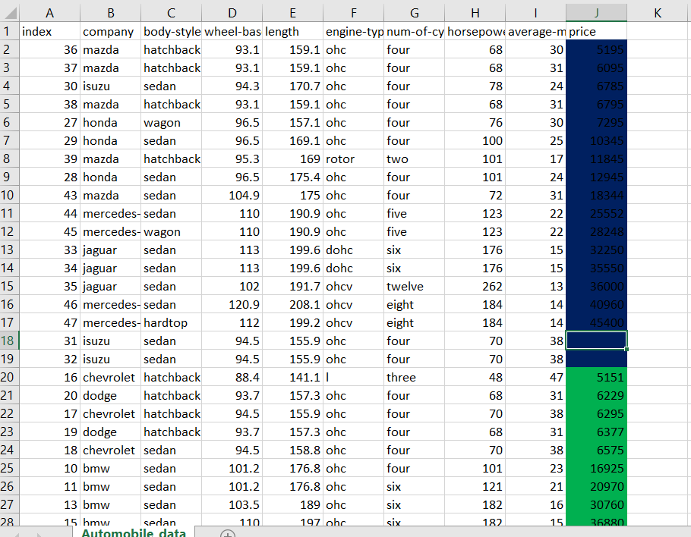

Sort the data on the basis of price with order with respect to color:

Yellow🡪 Blue🡪No Color🡪Green

First sort the data a-Z

Select a data cell and click sort

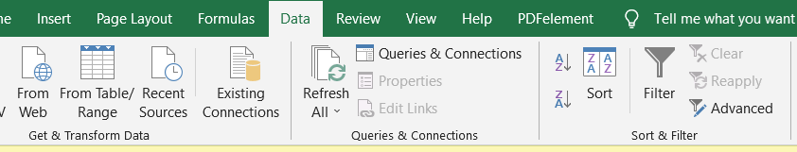

Select the priority of color and copy level accordingly .

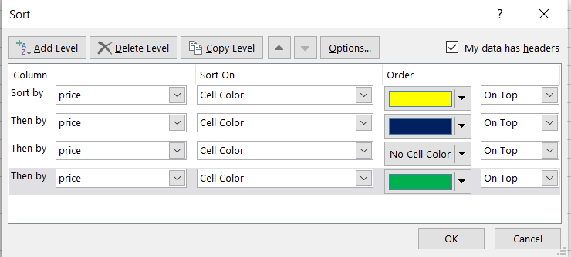

**By Values**

**Alphabetically / reverse alphabetically/ Custom list**

**Custom list: user can add their own list order**

**BY Dropdown**

**Ctrl+shift+L**